Screenshots of the SQL query result

- DESCRIBE the bank_transaction_dataset
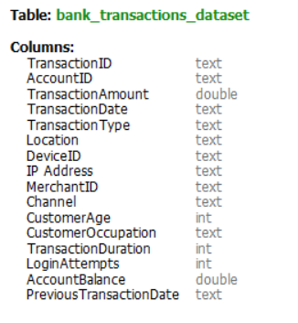

- Matching total records of the dataset
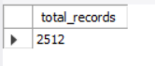

- Summary of the bank_transaction data
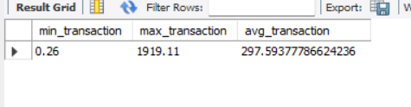

- Filter from the records, where transaction type is Credit through ATM of the Customer who's Age is greater than 70
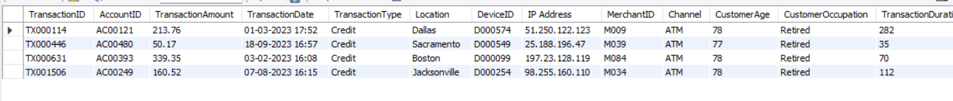

- Filter from the records, which location has Transaction Amount greater than 1000
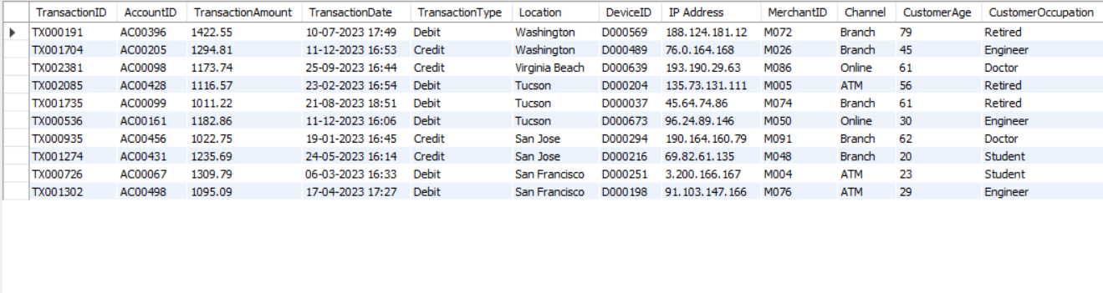

- Summary of Average of Customer's Age and sum of their Transaction Amount according to their Occupation and Transaction Type
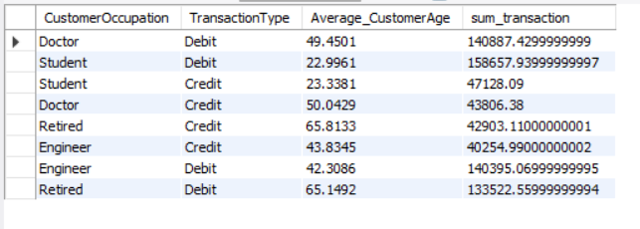

- Summary of the AccountID who's online login attempts > 20 with Location-wise
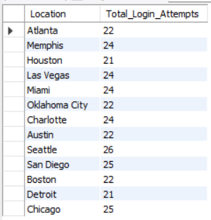

- Data Between Transaction Date
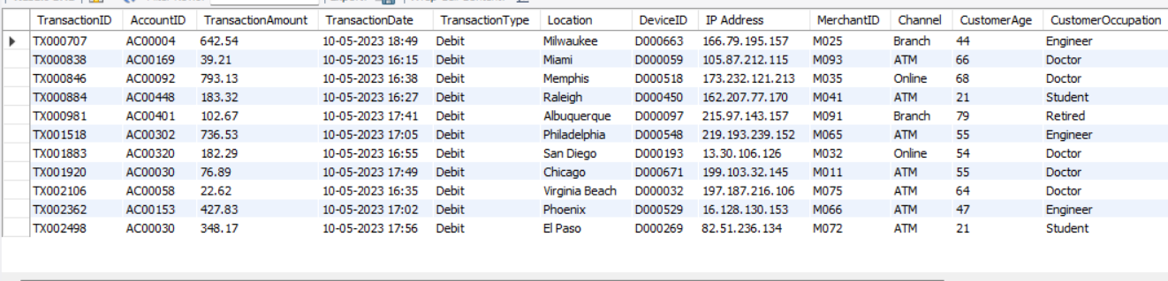
- Fetch data where AccountID LIKE '%AC00302%'
